Measure 1 Completer Impact and Effectiveness

Introduction
The Department of Teacher Education (DTE) at Northern New Mexico College (NNMC) entered into a state-wide partnership with New Mexico Public Education Department (NMPED) and other Colleges and University Education Preparation Programs (EPPs) to disseminate a survey created collaboratively with the partnership to gather data on program satisfaction and perceived program effectiveness.

NNMC DTE Post-Graduation -In partnership with NMPED, a New Mexico Educator Preparation Program Year-End Survey AY 2024-2025 was sent out to graduates. The statewide response rate was 178 respondents to NNMC’s N=24. Comparative data between the NMPED Agreement and NNMC provides a survey that has been developed by NMPED and administered statewide. The survey included the following information categories; Demographic, Programmatic, Clinical Practice, and Program Satisfaction. A summary of Statewide Comparative Information resulted in the following data; “Strongly” or “Somewhat agree”
-Based on what I was told when I was accepted, the program met my expectations- Statewide- N=178 85% NNMC N=24 96%
-I felt supported by my college faculty.
Statewide- N=178 91% NNMC N=24 96%
-I would highly recommend this program to others.
Statewide- N=178 89% NNMC N=24 96%

Process
DTE compiled a list of program graduates for the Fall 2024, Spring 2025, and Summer 2025 and provided the list and emails to the NMPED. They sent out a survey to all NNMC graduates asking them to respond to the survey, which would be automatically returned to NMPED. The state reported a total of 178 respondents state-wide. There was a total of 86 NNMC graduates that were sent a survey. Of the 86 graduates, 24 students participated. The response rate for NNMC was N=178 state-wide respondents/ NNMC N=24. The response rate for NNMC was highly impressive with total graduates N=86/ total respondents N=24 for a 31% rate of response.

Demographics
The participant demographics were as follows:
- Hispanic-13
- White-7
- Asian-2
- Native American- 2
- Other-7
- Gender: Female- 19
  - Male-3

Program
Bachelors- 15 graduates
- Elementary- 8
- Early Childhood- 7
Alternative – 9 graduates
- Elementary- 7
- Secondary- 2
- Special Education- 4

Results
Participants were prompted to share insights about their overall experience within their respective teacher education programs. The following is a summary of the topic questions and their responses. A list of questions asked can be found at the end of this document.

Program Satisfaction- Strongly Agree/somewhat agree
Based on what I was told when I was accepted, the program met my expectations- 86%

I felt supported by my college faculty- 96%

I would highly recommend this program to others- 96%

Program prepared you to be a first-year teacher- Strongly Agree/somewhat agree
There were 22 questions in total asked in the survey. Of those 22 questions, 17 of those questions received a score of 96% strongly agree/somewhat agree.

Two questions received a score of 95% strongly agree/somewhat agree.

Three questions received a score of 93% strongly agree/somewhat agree.

Next steps
The DTE will continue to support the state-wide partnership in administering the New Mexico Educator Preparation Program Year-End Survey. The DTE will also make efforts to re-continue the Focus groups to collect additional graduate data.
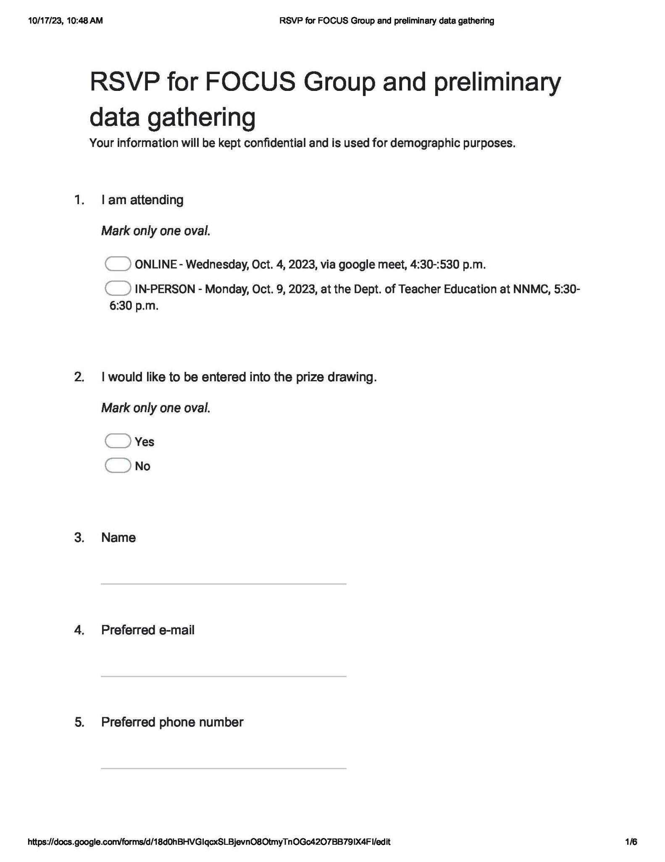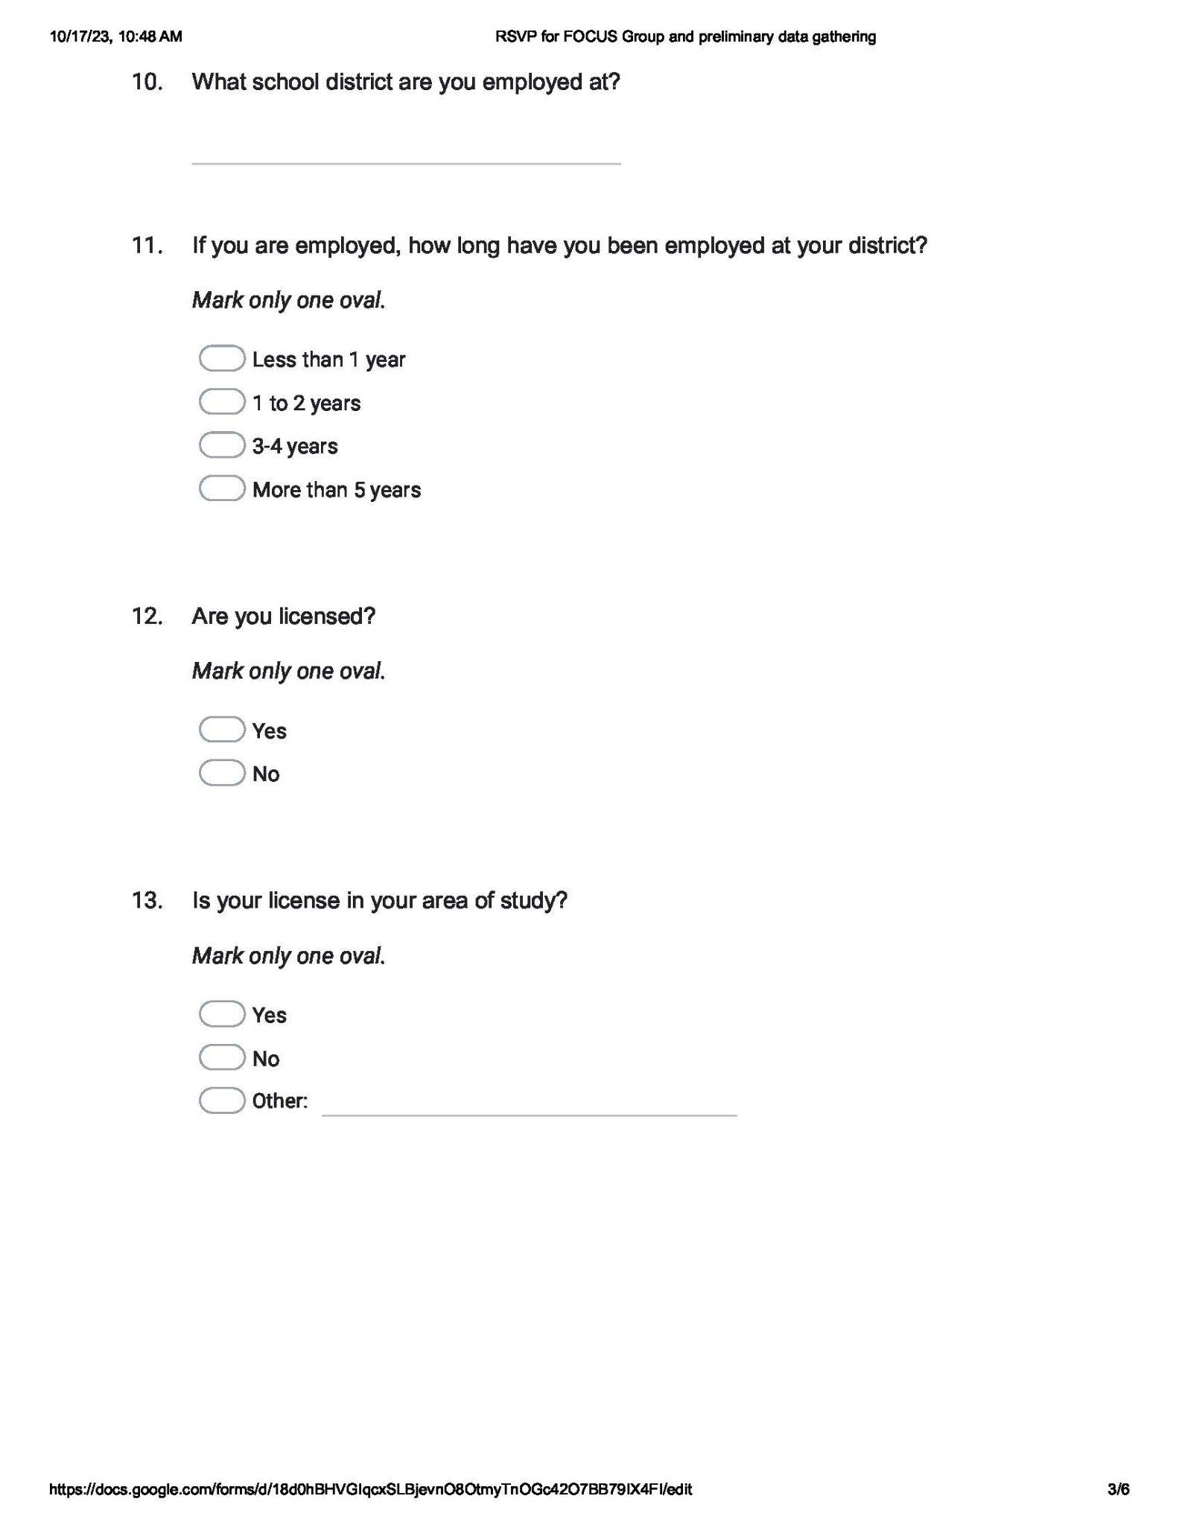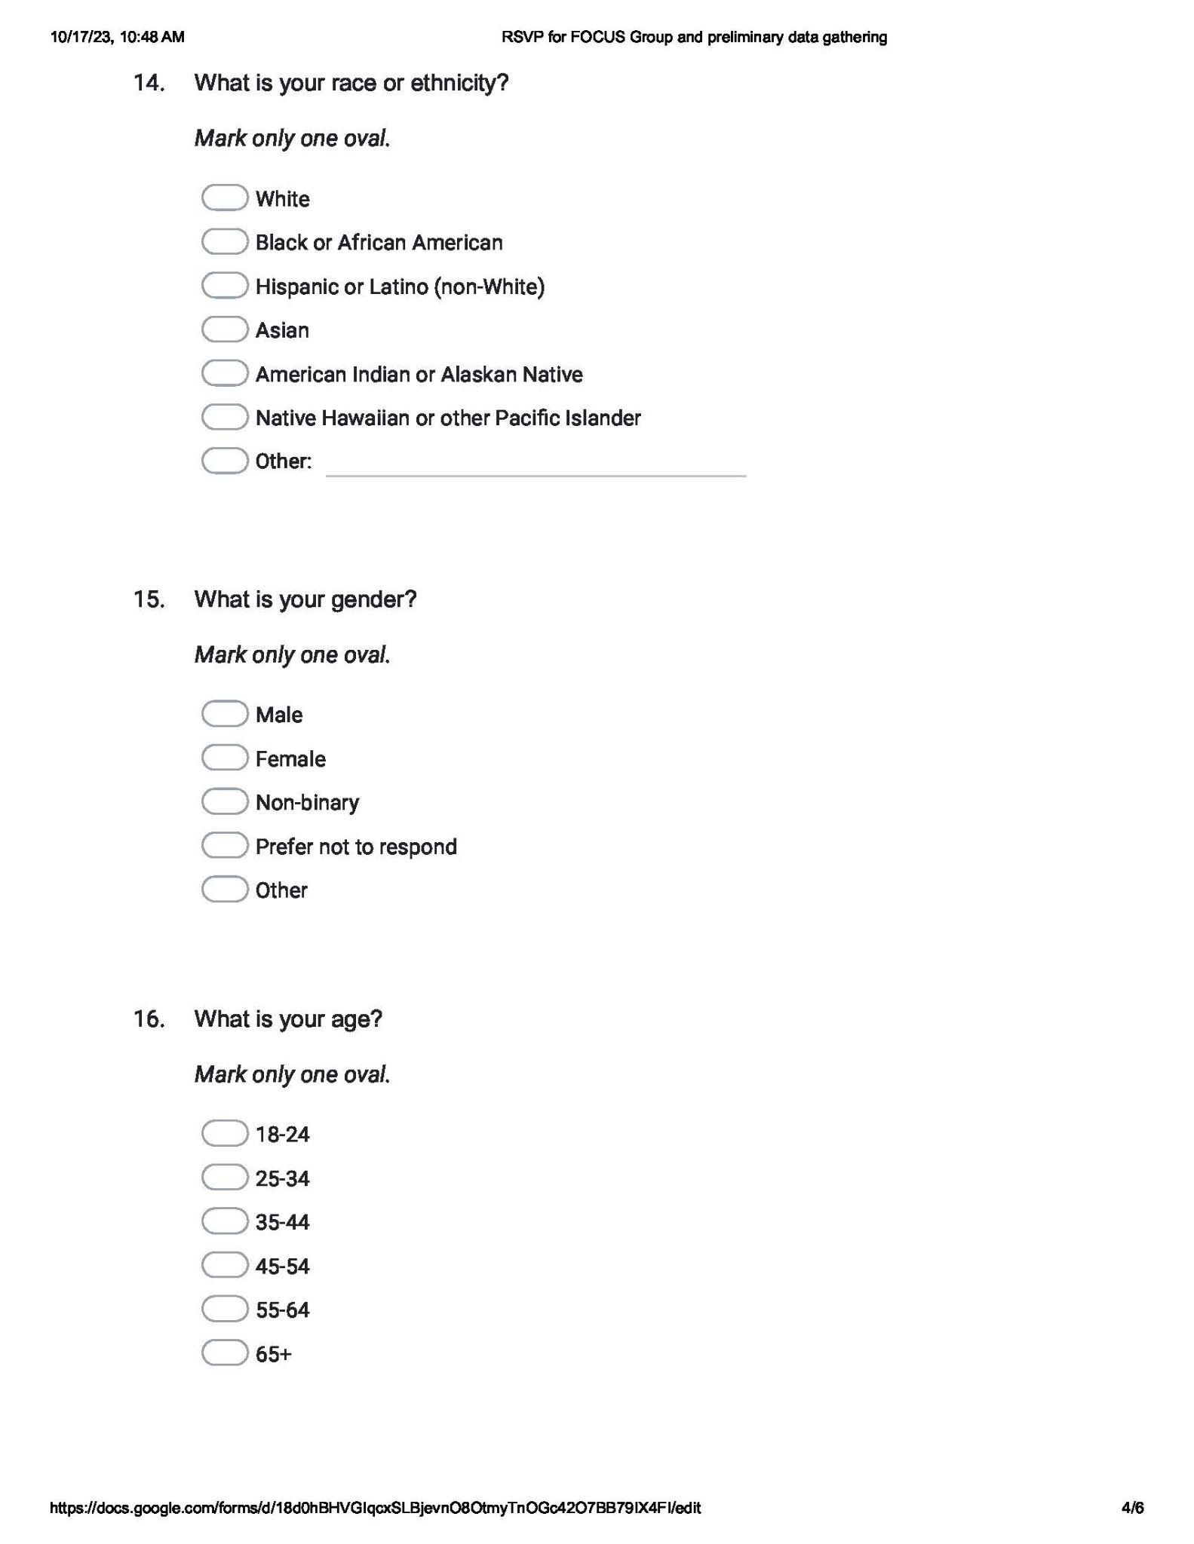

Demographic survey results
